**GraspMMI User’s Manual v1.0**

Prepared by: J. McIntyre

The GraspMMI is launched using the DOS batch file RunGRASPMMI.bat. It launches 3 processes.

* “DexGroundMonitorClient” runs in a DOS window. It communicates with the EPM and deposits packets pertinent to Grasp in a local cache buffer.
* “GraspMMI Mirror” provides an indication of what the user is seeing on the Perspectives laptop on board the ISS in terms of the GraspGUI graphical interface.
* “GraspMMI Data Plots” provides a graphical representation of the history of Grasp since midnight of the current day.

Copious comments in RunGRASPMMI.bat indicate how this batch file should be edited in order to match the configuration of a given installation (server addresses, cache file locations, EPM software unit IDs, etc.) and are not repeated here.

***GraspMMI Data Plots***

The graphical presentation is divided into 6 zones that function as follows:

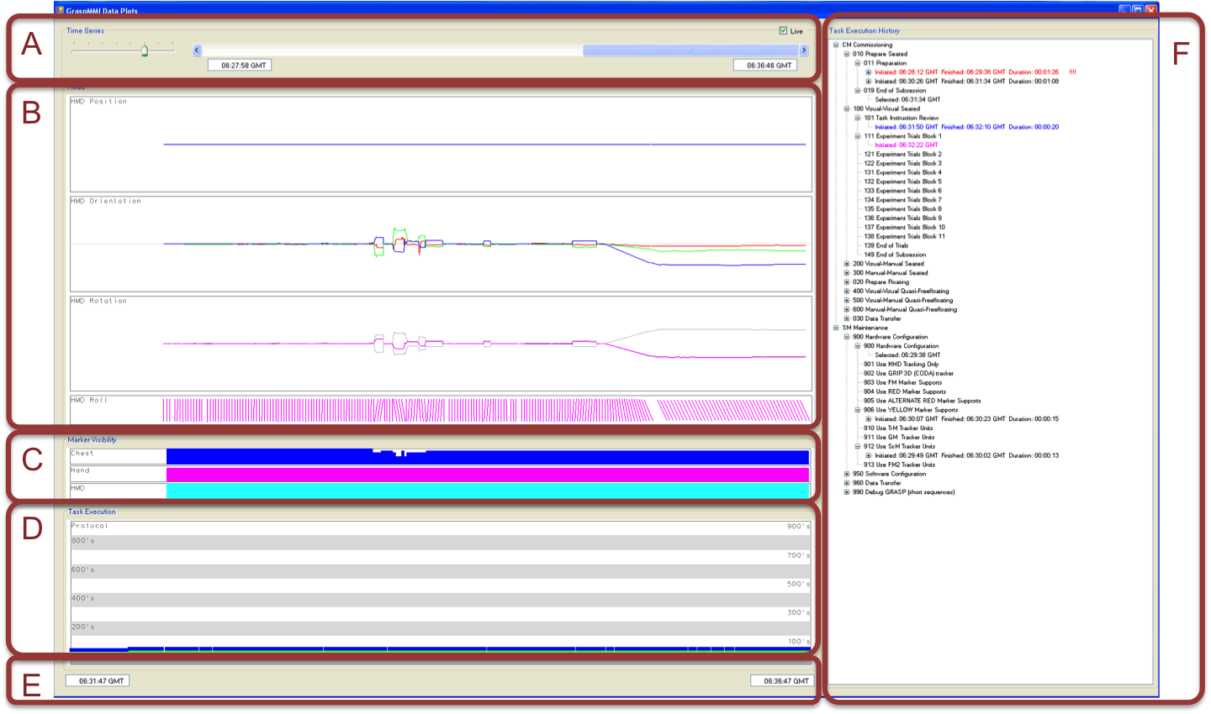

1. Time Span and Epoch

* The user selects the time span of the data displays by manipulating the selector on the left. Far left position sets for a time span of 12 hours, far right position corresponds to 30 seconds.
* The scroll bar allows the user to look back in time to previous records. The “live” button indicates whether the display is being updated according to the latest telemetry packets or if it is frozen looking at an earlier epoch.

1. Head Position and Orientation

* Data about the head position and orientation are display as strip-charts showing a) the 3D position, b) the 3D head orientation reported as the imaginary components of the head orientation quaternion, c) the amplitude of the head rotation away from the straight ahead (grey) plus the roll component (pink) and d) a representation of the head’s roll angle shown as a tilted line segment.
* By default, graph limits correspond to ±50 cm for position and ±90° for orientation. Plots can be autoscaled by clicking right on the graphs and checking the autoscale item.

1. Marker Visibility

* The number of markers visible for each marker structure is displayed as a strip chart. Range on each plot is 0 – 8 markers.

1. Task Timeline

* The session and task numbers are plotted as strip charts. One can focus on a specific session by right clicking on the graph and selecting the session of interest.

1. Time Span Indicator

* Text boxes indicate the time of day corresponding to the left and right edges of the strip charts. These vary as a function of the time span and epoch chosen in zone A.

1. Task History Tree

* The sessions and tasks programmed for each subject or operator appear in a hierarchical tree. Branches of the tree can be expanded or collapsed by clicking on the + and – symbols next to each parent node.
* As the operator selects each task, it’s corresponding item in the list turns magenta. When the task completes the corresponding line turns to green for nominal exit, red if there was an anomalous exit from one or more steps and blue for an unknown exit code.
* A leaf is added to each node of the tree as each step within the task exits. If a task is executed multiple times, a leaf is added for each execution, providing a means to visually verify which steps and tasks have been performed and repeated and whether they were successful or not.
* Nodes for tasks that exit with an error code remain highlighted in red after the task has been completed and the subject has moved on to another task. Clicking right on the item and choosing the appropriate action in the contextual menu can remove the highlighting for an individual task. The contextual menu also provides the possibility to clear all highlighted items to black and to reconstruct the tree so as to re-highlight all items with error exits.